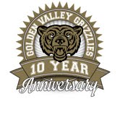
Golden Valley High School
Wm. S. Hart Union High School District
“Home of the Grizzlies”
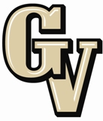

Parent Advisory Council (PAC) Meeting
May 11, 2015
6:30 PM

AGENDA

- PAC Meeting Welcome Sal Frias

- Secretary’s Report ACTION Jennifer Ryan

- Treasurer’s Report ACTION Emily Curtis

- President’s Report Sue Alterman

- District Advisory Council (DAC) Report Colleen Villani

- Parent Communications Council (PCC) Report Suzanne Holmes

- Athletic Department Robert Fisher

- World Language Courtney Straka

- “Healthy Relationships” Club Jessica Romo, Program Manager
Karissa Valencia, Program Director

Announcements: - CAHSEE Make Ups for no shows and 11th and 12th graders is May 12th and 13th
- May 13th ROTC Awards
- May 14th Band Concert
- May 15th Choir Concert
- May 18th Baseball Banquet; Band Banquet; Theater Banquet
- May 20th ASB Awards
- May 21st Senior Awards
- May 22nd Swim Awards
- May 26th Track Banquet
- May 27th Boys Volleyball Banquet
- May 28th Circle of Friends Banquet
- June 1st GVHS 2015 Graduation

Next Meeting: TBD

The mission of GVHS is to provide a quality education to a diverse student population, develop each student’s maximum potential, and prepare students for success in the global community.

